|  |  |  |  |  |  |  |  |  |  |
| --- | --- | --- | --- | --- | --- | --- | --- | --- | --- |
| **SCHOOL OF COMPUTER SCIENCE AND ARTIFICIAL INTELLIGENCE** | | | | | **DEPARTMENT OF COMPUTER SCIENCE ENGINEERING** | | | | |
| **Program Name:** B. Tech | | | | **Assignment Type: Lab** | | | **Academic Year:**2025-2026 | | |
| **Course Coordinator Name** | | | | Venkataramana Veeramsetty | | | | | |
| **Instructor(s) Name** | | | | |  | | --- | | Dr. V. Venkataramana (Co-Ordinator) | | Dr. T. Sampath Kumar | | Dr. Pramoda Patro | | Dr. Brij Kishor Tiwari | | Dr.J.Ravichander | | Dr. Mohammand Ali Shaik | | Dr. Anirodh Kumar | | Mr. S.Naresh Kumar | | Dr. RAJESH VELPULA | | Mr. Kundhan Kumar | | Ms. Ch.Rajitha | | Mr. M Prakash | | Mr. B.Raju | | Intern 1 (Dharma teja) | | Intern 2 (Sai Prasad) | | Intern 3 (Sowmya) | | NS_2 ( Mounika) | | | | | | |
| **Course Code** | | | 24CS002PC215 | **Course Title** | | AI Assisted Coding | | | |
| **Year/Sem** | | | II/I | **Regulation** | | R24 | | | |
| **Date and Day**  **of Assignment** | | | Week1 - Monday | **Time(s)** | |  | | | |
| **Duration** | | | 2 Hours | **Applicable to**  **Batches** | | 24CSBTB01 To 24CSBTB39 | | | |
| **Assignment Number: 2.1**(Present assignment number)/**24**(Total number of assignments) | | | | | | | | | |
|  | | | | | | | | | |
|  | **Q.No.** | **Question** | | | | | | ***Expected Time***  ***to complete*** |  |
|  | 1 | Lab 2: Exploring Additional AI Coding Tools – Gemini (Colab) and Cursor AI  **Lab Objectives:**   * To explore and evaluate the functionality of Google Gemini for AI-assisted coding within Google Colab. * To understand and use Cursor AI for code generation, explanation, and refactoring. * To compare outputs and usability between Gemini, GitHub Copilot, and Cursor AI. * To perform code optimization and documentation using AI tools.   **Lab Outcomes (LOs):**  After completing this lab, students will be able to:   * Generate Python code using Google Gemini in Google Colab. * Analyze the effectiveness of code explanations and suggestions by Gemini. * Set up and use Cursor AI for AI-powered coding assistance. * Evaluate and refactor code using Cursor AI features. * Compare AI tool behavior and code quality across different platforms.   Task Description #1   * Use Google Gemini in Colab to write a Python function that reads a list of numbers and calculates the mean, minimum, and maximum values.   Expected Output #1   * Functional code with correct output and screenshot.   Task Description #2   * Compare Gemini and Copilot outputs for a Python function that checks whether a number is an Armstrong number. Document the steps, prompts, and outputs.   Expected Output #2   * Side-by-side comparison table with observations and screenshots.   Task Description #3   * Ask Gemini to explain a Python function (e.g., is_prime(n) or is_palindrome(s)) line by line. * Choose either a prime-checking or palindrome-checking function and document the explanation provided by Gemini.   Expected Output #3   * Detailed explanation with the code snippet and Gemini’s response.   Task Description #4   * Install and configure Cursor AI. Use it to generate a Python function (e.g., sum of the first N natural numbers) and test its output. * Optionally, compare Cursor AI’s generated code with Gemini’s output.   Expected Output #4   * Screenshots of Cursor AI setup, prompts used, and generated code with output.   Task Description #5   * Students need to write a Python program to calculate the sum of odd numbers and even numbers in a given tuple. * Refactor the code to improve logic and readability.   Expected Output #5   * Student-written refactored code with explanations and output screenshots.   **Note:**   * Students must submit a single Word document including:   + Prompts used for AI tools   + Copilot/Gemini/Cursor outputs   + Code explanations   + Screenshots of outputs and environments   **Evaluation Criteria:**   | **Criteria** | **Max Marks** | | --- | --- | | Successful Use of Gemini in Colab (Task#1 & #2) | 1.0 | | Code Explanation Accuracy (Gemini) (Task#3) | 0.5 | | Cursor AI Setup and Usage (Task#4) | 0.5 | | Refactoring and Improvement Analysis (Task#5) | 0.5 | | **Total** | **2.5 Marks** | | | | | | | Week1 - Monday |  |

Task Description #1

* Use Google Gemini in Colab to write a Python function that reads a list of numbers and calculates the mean, minimum, and maximum values.

Expected Output #1

* Functional code with correct output and screenshot.

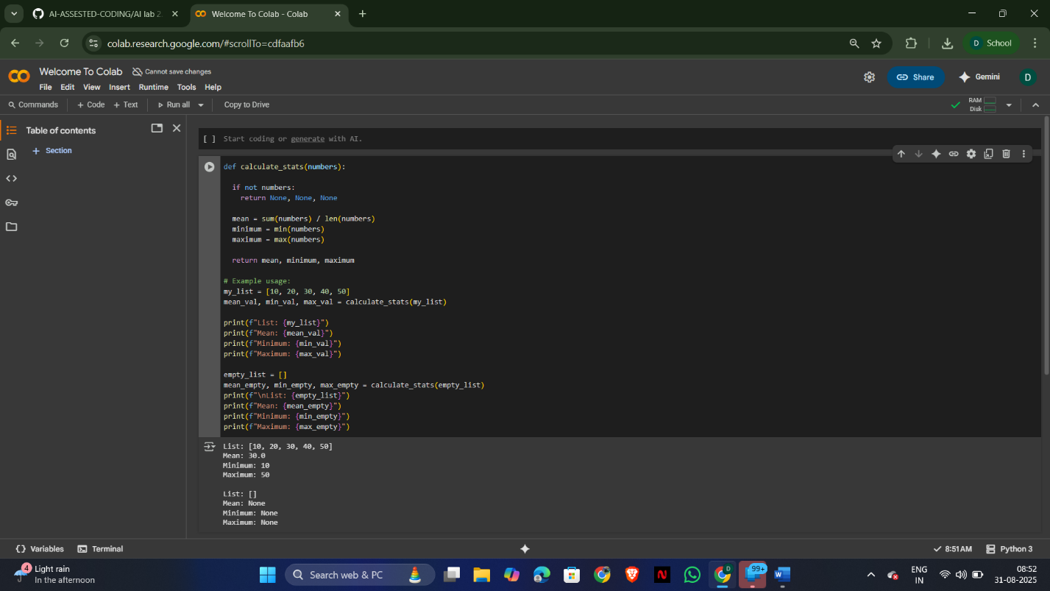

Task Description #2

* Compare Gemini and Copilot outputs for a Python function that checks whether a number is an Armstrong number. Document the steps, prompts, and outputs.

Expected Output #2

* Side-by-side comparison table with observations and screenshots.

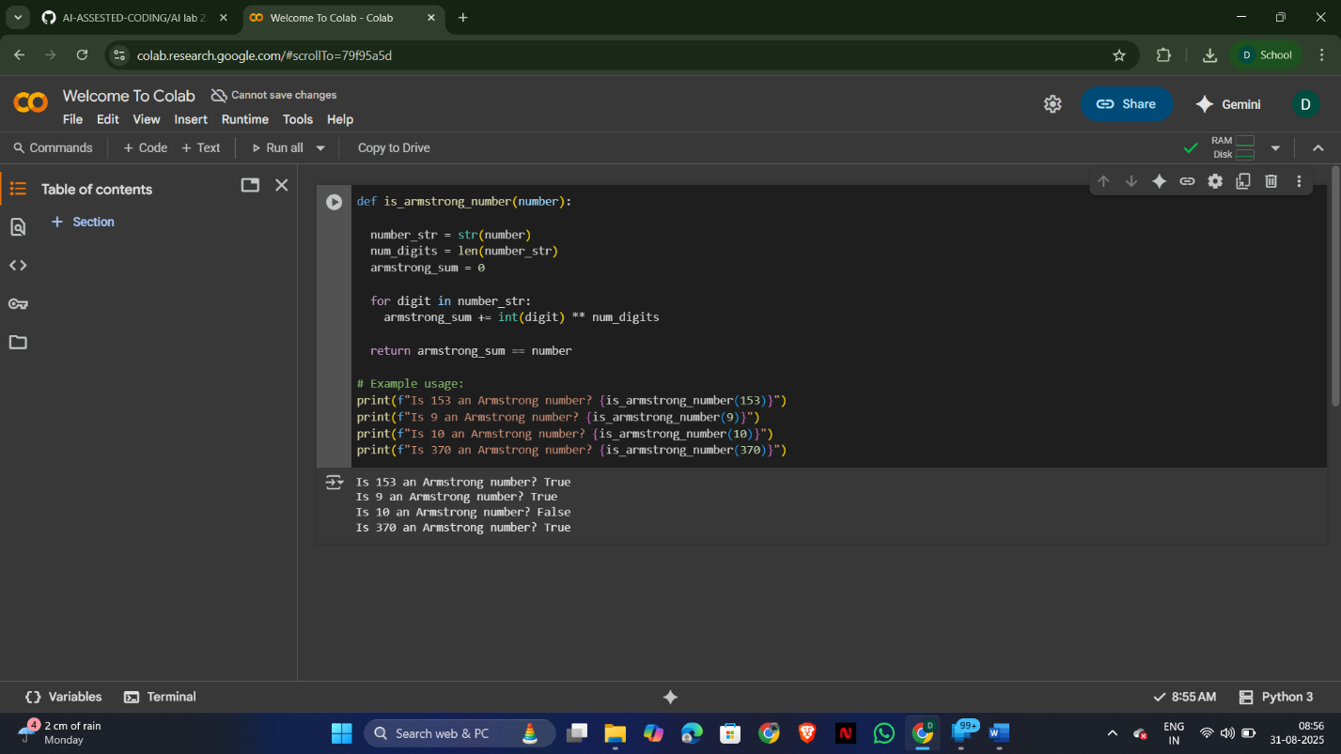

Task Description #3

* Ask Gemini to explain a Python function (e.g., is_prime(n) or is_palindrome(s)) line by line.
* Choose either a prime-checking or palindrome-checking function and document the explanation provided by Gemini.

Expected Output #3

* Detailed explanation with the code snippet and Gemini’s response.

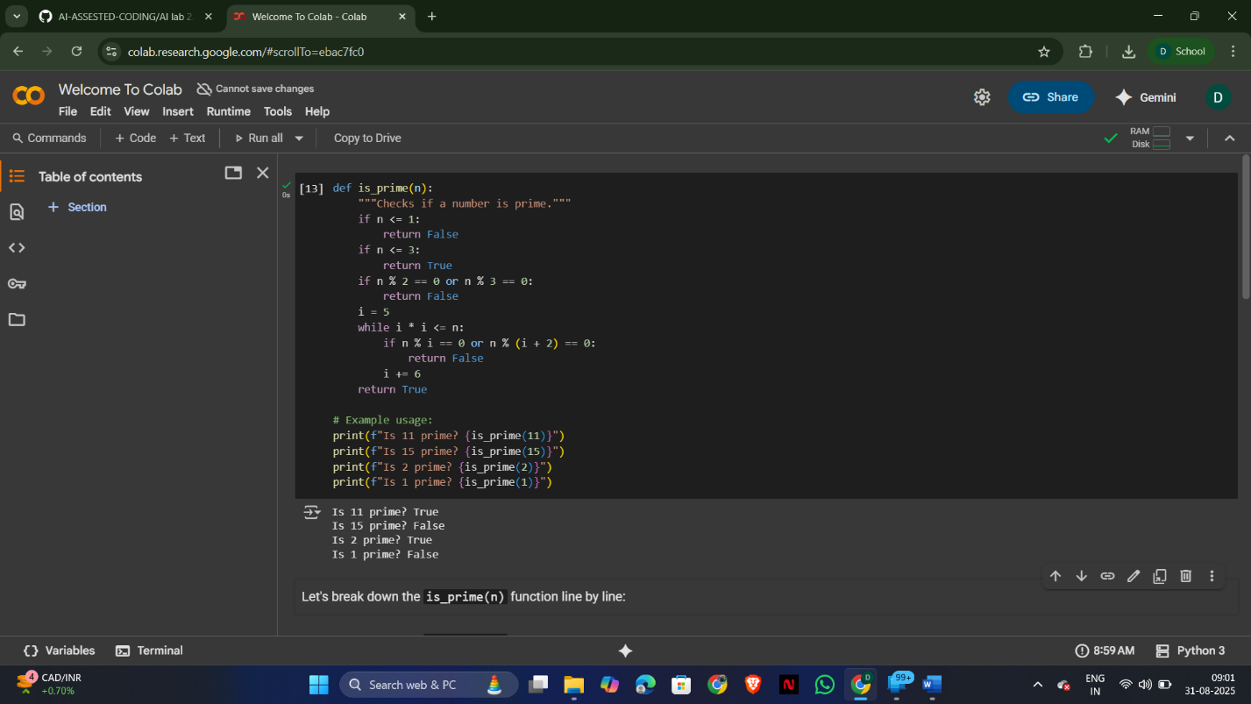

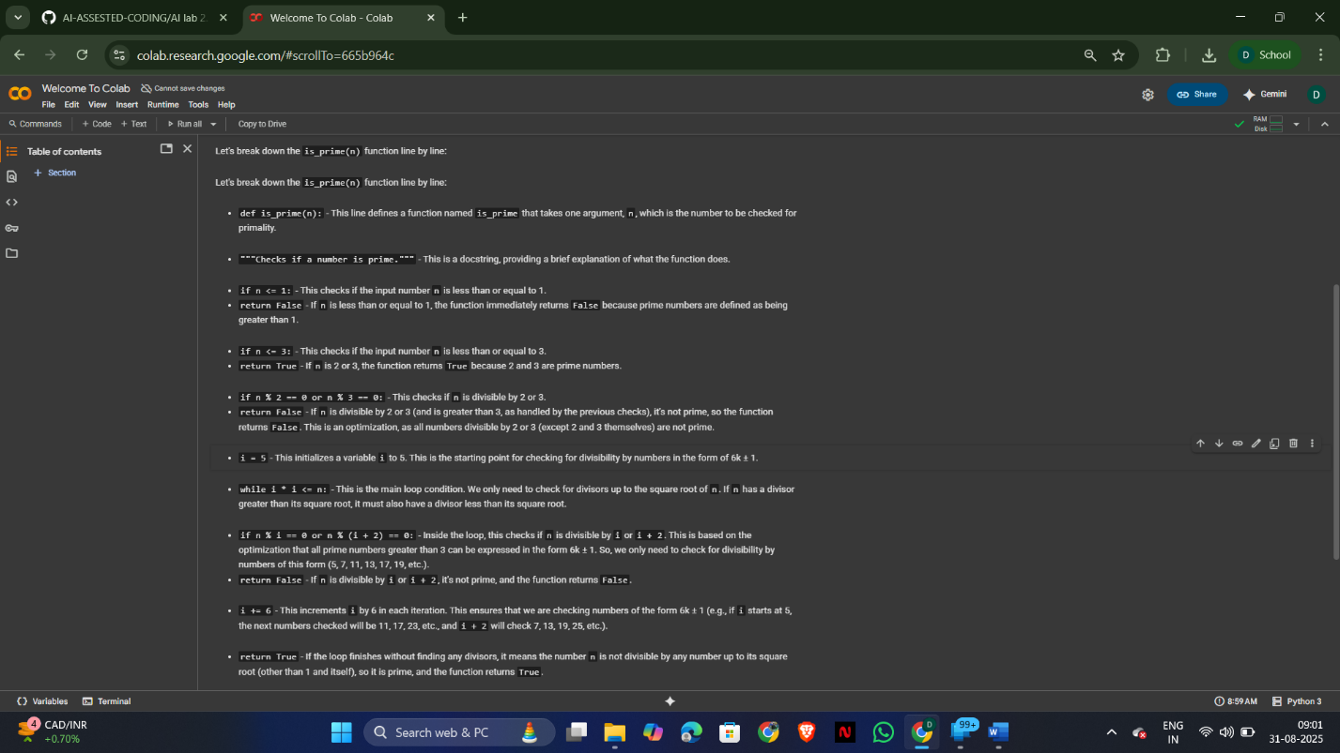

Task Description #4

* Install and configure Cursor AI. Use it to generate a Python function (e.g., sum of the first N natural numbers) and test its output.
* Optionally, compare Cursor AI’s generated code with Gemini’s output.

Expected Output #4

* Screenshots of Cursor AI setup, prompts used, and generated code with output.

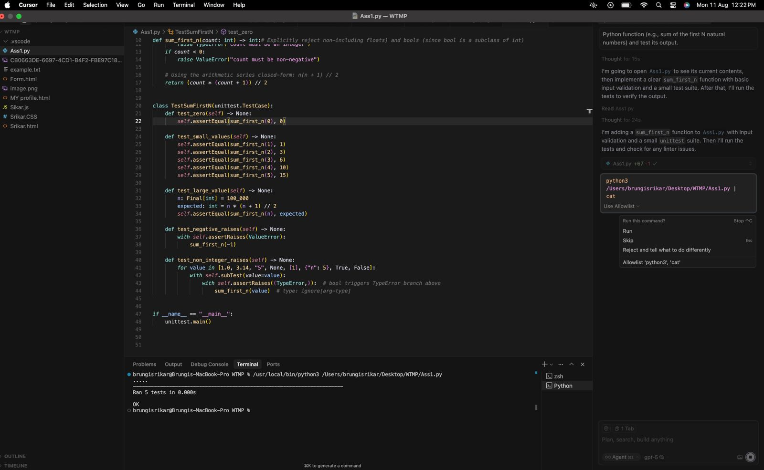

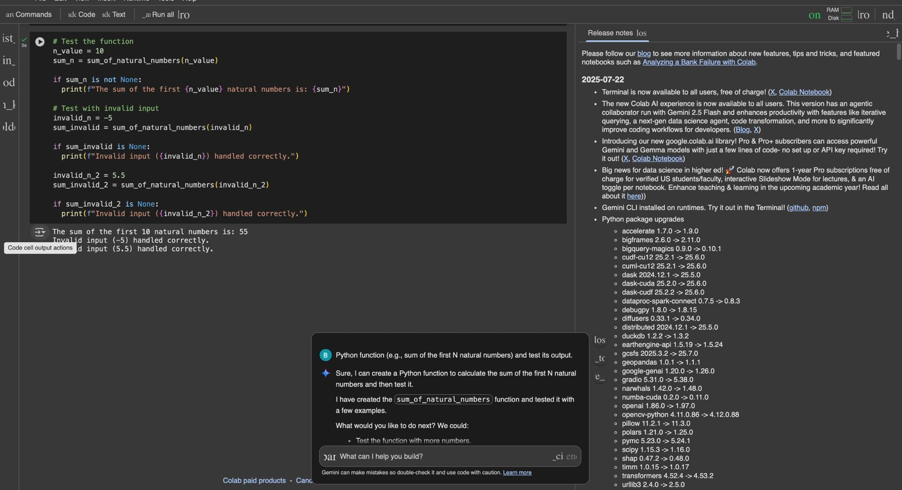

Task Description #5

* Students need to write a Python program to calculate the sum of odd numbers and even numbers in a given tuple.
* Refactor the code to improve logic and readability.

Expected Output #5

* Student-written refactored code with explanations and output screenshots.

